LED Bar Lights
User Manual

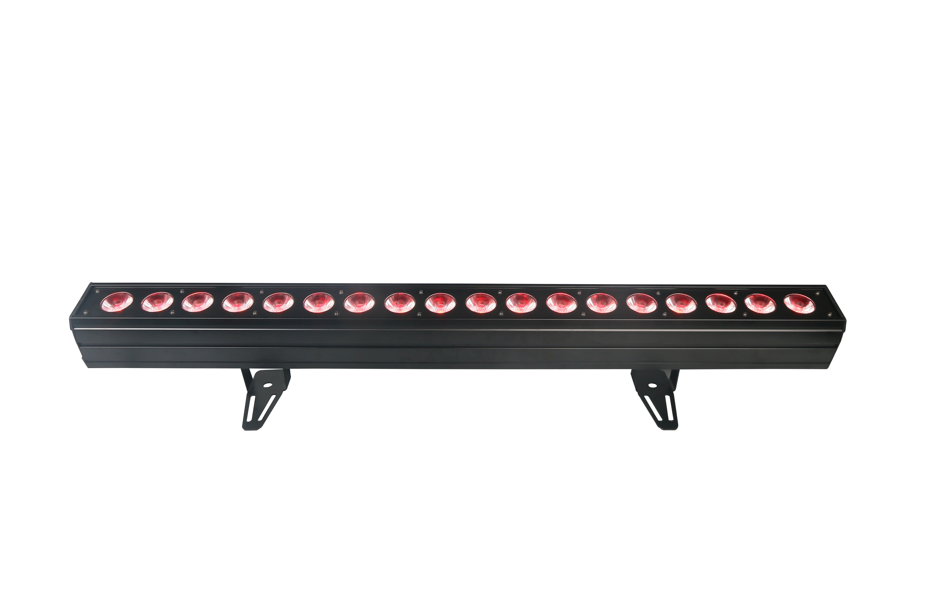

Please keep the manual carefully for future reference

Introduction
Thank you for buying our product. We are confident that our excellent products and service can satisfy you. For your own safety, please read this user manual carefully before installing the device.
In order to install , operate, and maintain the lighting safety and correctly. We suggest that the installation and operation should be done by the verified technician and follow the instruction strictly.

Checking Parts
Please check if the following parts are included:
● 1 x Led light
● 1 x Power cable
● 1 x User manual

Please check carefully that there is no damage caused by transportation. Should there be any, consult your local dealer

Caution
This device has left our premises in absolutely perfect condition. In order to maintain this condition and to ensure a safe operation, it is absolutely necessary for the user to follow the safety instructions and warning notes written in this user manual.

We cannot be made liable for damages caused by incorrect installations and unskilled operation!


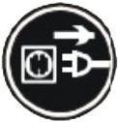
CAUTION!
Keep this device away from rain and moisture!

Unplug mains lead before opening the housing!


Warning!

Damages caused by the disregard of this user manual are not subject to warranty. The dealer will not accept liability for any resulting defects or problems.

Symbol Instruction On The Device

-------------------------------------------------------------------------------CE certificate

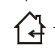

---------------------------------------------------------------------------Only indoor using



------------------------------------------------------------------------------RoHS certificate

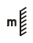
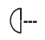
----------------------------------The minimum distance from lighted objects (meter)

Safety instruction
- If the device has been exposed to temperature changes due to environmental changes, do not switch it on immediately. The arising condensation could damage the device. Leave the device switched off until it has reached room temperature.
- Please make sure that the device be earthed.
- Please replace housing if it is broken. This fixture can be using after finished installed.
- The electric connection must carry out by qualified person.
- Make sure that the available voltage is not higher than stated at the end of this manual.
- Make sure the power cord is never crimped or damaged by sharp edges. If this would be the case, replacement of the cable must be done by an authorized dealer.
- If the external flexible cable or cord of this luminaire is damaged, it shall be exclusively replaced by the manufacturer or his service agent or a similar qualified person in order to avoid a hazard.
- Please cut off the power if don't use the fixture or want to clean, maintenance.

Installation
- When install this equipment please make sure there's no flammable surfaces (decorated things, etc) within at least 0.5M distance from flammable surfaces.
- Please make sure that there's no other equipment or decorating materials obstructed the exhaust fan and the vent-pipe.
- Products should be install immobility.
In case of safety, it's very important that to connect the earth with line.

Product Specification
- 12/110 DMX512 channels
- Sound-Active/Auto-Play/DMX 512/Master-Slave
- LED display
- Built-in different inner program, can invoked directly.
- 3-pins XLR
- Power supply: AC100V-240V 50/60Hz
- Rated power: 133W
- LED: 18PCS 10W RGBWA-UV 6in1 LED
- Dimmer: 0-100% linear 32bits
- IP rating: IP20
- Housing: black metal
- Max ambient Temp:-30- 45°C.

LED digit display menu:
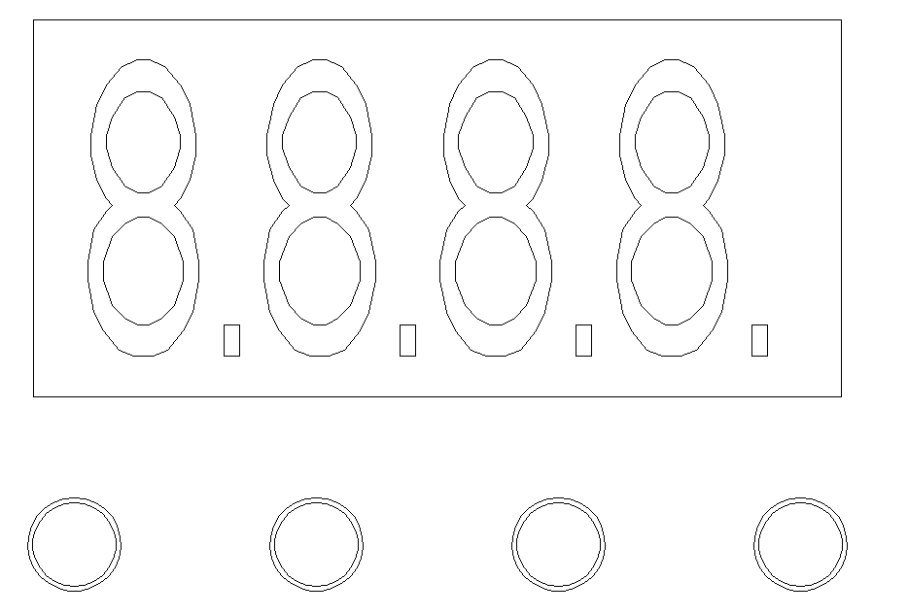
A: MENU

B: DOWN

C: UP

D: ENTER

A B C D

Operation instruction: Press button A will cycle display 10 different functions effect, the front two value of LED digit means the current function( see function map). The end two value means functions’ address and speed. Press B or C can adjust different value, press D to enter.

LED digit display menu instruction
Addr | A001-A512 | DMX mode, press"DOWN/UP" to modify value.
CHnd | 12CH/110CH | choose 12 or 110 channel
SLnd | Auto | auto mode for master unit
SLnd | Soun | sound mode for master unit
SLnd | SL 1 | DMX mode
SLnd | SL 2 | slave unit mode
SHnd | 0-85 | choose auto effect for master unit
Clor | 1-32 | choose color for master unit auto mode
Sped | 0-100 | set auto speed
Sens | 0-100 | set sensitivity
r*** | 0-255 | red dimmer
G*** | 0-255 | green dimmer
b*** | 0-255 | blue dimmer
W*** | 0-255 | white dimmer
A*** | 0-255 | yellow dimmer
P*** | 0-255 | purple dimmer
LEd | OFF | display OFF in 5 seconds
LEd | ON | display ON

[MENU] key:

Press this key in normal mode to enter edit mode; Press this key in editing status to return to the previous directory. After entering edit mode, if there is no button pressed for 30 seconds, the light will automatically exit edit mode.

[Up] key:

Press this key to increase the address value; Continuously holding down this key will quickly increase the address value. If there is no button pressed for 30 seconds, it will automatically exit the flash status. Pressing this key in edit mode will select the function menu in the current level directory from bottom to top (as shown in the table below).

[Down] key:

Press this key in normal mode to decrease the address value: If you continue to press and hold this key, the address value will quickly decrease. If there is no button pressed for 30 seconds, it will automatically exit the flashing state. Pressing this key in edit mode will select the function menu in the current level directory in order from top to bottom (see table below).

[Enter] key:

Pressing this key in normal mode has no effect. Pressing this key in edit mode will enter the next level directory of the current menu function item. Please refer to the operations in each function menu for specific operations.

DMX512 12 channels instruction
Channel | value | Function
1 | 0-255 | master dimmer
2 | 0-255 | strobe
3 | 0-255 | red dimmer/auto choose color
4 | 0-255 | green dimmer/auto choose color
5 | 0-255 | blue dimmer/auto choose color
6 | 0-255 | white dimmer/auto choose color
7 | 0-255 | yellow dimmer/auto choose color
8 | 0-255 | purple dimmer/auto choose color
9 | 0 | no function
9 | 1-182 | effect（0-60）,can choose background color
9 | 183-255 | effect（61-85 multi color auto）,can't choose background color
10 | 0-255 | auto speed
11 | 0-255 | auto effect background color
12 | 0-255 | background color dimmer

Channel | value | function
1 | 0-255 | master dimmer
2 | 0-255 | strobe
3 | 0-255 | LED 1 red dimmer
4 | 0-255 | LED 1 green dimmer
5 | 0-255 | LED 1 blue dimmer
6 | 0-255 | LED 1 white dimmer
7 | 0-255 | LED 1 yellow dimmer
8 | 0-255 | LED 1 purple dimmer
…………………………………………………………………………
105 | 0-255 | LED 18 red dimmer
106 | 0-255 | LED 18 green dimmer
107 | 0-255 | LED 18 blue dimmer
108 | 0-255 | LED 18 white dimmer
109 | 0-255 | LED 18 yellow dimmer
110 | 0-255 | LED 18 purple dimmer

DMX-512 control connection
3-Pins DMX Out 3-Pins DMX In
(Female) (Male)

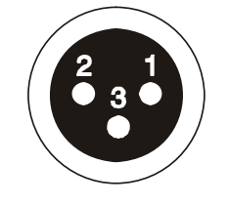
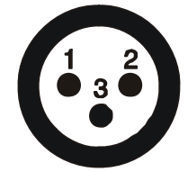

- Earth 2. DMX- 3. DMX+
Take 12CH as an example:
Address code: 1
The 4th unit

Power In
Power Out
The 1st unit (001)
The 2nd unit (013)
The 3rd unit (025)

DMX address setting
Each fixture must set a specific starting address. When receiving signal transmission, fixture will receive channel control signals which from the starting address.
According to different requirements or easy to use, the user can set many value fixtures to the same address, also can set up a separate address for every device.
If you set the same address, all the devices will receive from DMX channels signal. All connecting fixtures are jointly controlled, controller can't separate control a device.
If you set a different address, each device will be separate from its particular set the starting address and begin accepting DMX512 control signal, so that more convenient separate control one device. Using this method must be based on channel quantity of device to determine a starting address.
This led light has 12/110 channels. When you choose 12 channels mode, you should set the starting address of the first unit to 1, the second unit to 13(12+ 1), the third unit to 25 (24+ 1), and so on. When you choose 110 channels mode, you should set the starting address of the first unit to 1, the second unit to 111(110+ 1), the third unit to 221(220+ 1), and so on.

Cleaning and maintenance

Cleaning should be performed every 15-day period, by using a sponge which is dipped with alcohol, rather than wet cloth or other chemical liquid, to clean the mirror.
Cut off power before cleaning and maintenance!
CAUTION

Attention

Do not see directly light source when open the light, and make sure power off before do any installation or maintenance.
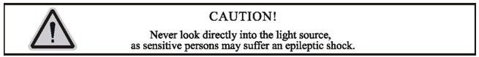
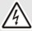 Wires connection must be professional person!
CAUTION

Warranty Card
Wires connection
Display board

DMX

We will provide 1 year warranty under the condition that user has operated the light normally and lifetime service. We won't provide warranty if the damage is caused by artificial or force majeasure event. Please cut this warranty card and shipped it along with the product to our factory when applying for warranty.
Product：
Purchasing date：
Code of invoice：
Warranty date: From To
User’s name： Add：
Company： Tel：

